- Program ID : VI003MA1

- Display Layout
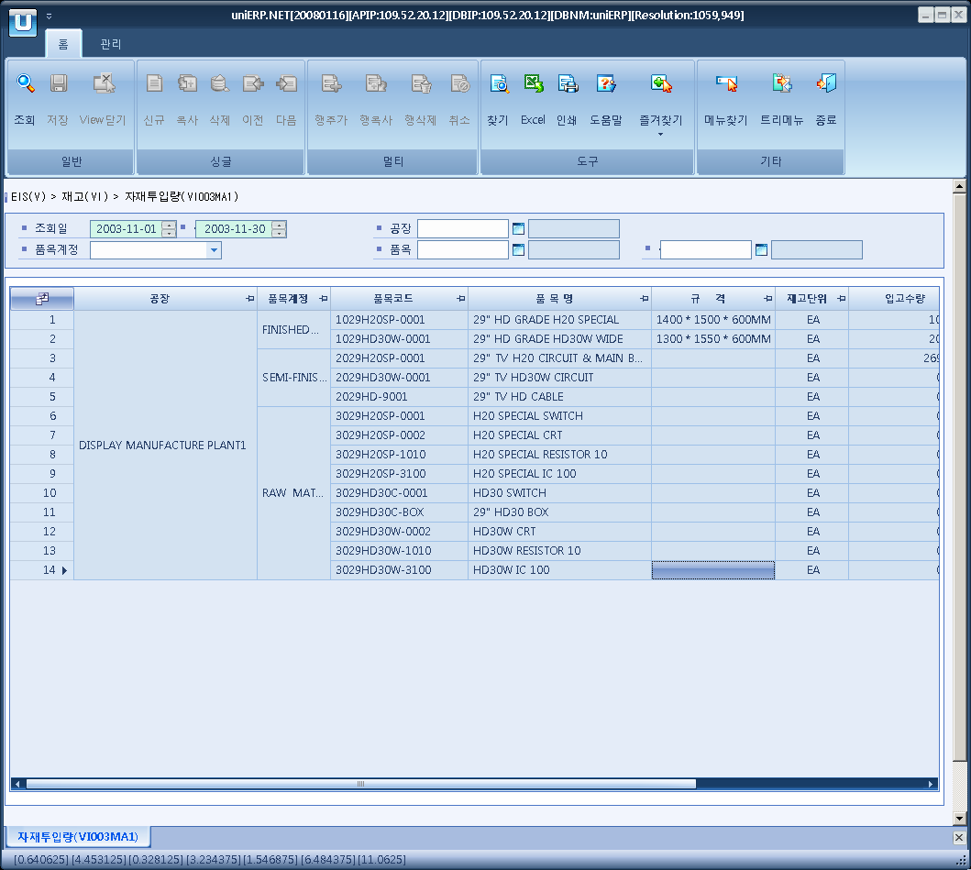

- Event flow
- Click Query button
- OnFncQuery -> DbQuery -> DataChange
- Display Unit combo change
- uniCombo1_ValueChanged -> DataChange

- SQL Statements
- Monthly sales status
SELECT B_ITEM_BY_PLANT.PLANT_CD, B_PLANT.PLANT_NM, B_ITEM_BY_PLANT.ITEM_ACCT, B_MINOR.MINOR_NM,
I_GOODS_MOVEMENT_DETAIL.ITEM_CD, B_ITEM.ITEM_NM, B_ITEM.SPEC, B_ITEM.BASIC_UNIT,
SUM(case when I_GOODS_MOVEMENT_DETAIL.TRNS_TYPE in ('MR','PR') then
(case when I_GOODS_MOVEMENT_DETAIL.DEBIT_CREDIT_FLAG = 'D' then I_GOODS_MOVEMENT_DETAIL.QTY
else I_GOODS_MOVEMENT_DETAIL.QTY*(-1) end)
else 0 end),
SUM(case when I_GOODS_MOVEMENT_DETAIL.TRNS_TYPE in ('DI','PI') then
(case when I_GOODS_MOVEMENT_DETAIL.DEBIT_CREDIT_FLAG = 'C' then I_GOODS_MOVEMENT_DETAIL.QTY
else I_GOODS_MOVEMENT_DETAIL.QTY*(-1) end)
else 0 end),
CASE SUM(case when I_GOODS_MOVEMENT_DETAIL.TRNS_TYPE in ('MR','PR') then
(case when I_GOODS_MOVEMENT_DETAIL.DEBIT_CREDIT_FLAG = 'D' then I_GOODS_MOVEMENT_DETAIL.QTY
else I_GOODS_MOVEMENT_DETAIL.QTY*(-1) end)
else 0 end)
WHEN 0 THEN 0
ELSE SUM(case when I_GOODS_MOVEMENT_DETAIL.TRNS_TYPE in ('DI','PI') then
(case when I_GOODS_MOVEMENT_DETAIL.DEBIT_CREDIT_FLAG = 'C' then I_GOODS_MOVEMENT_DETAIL.QTY
else I_GOODS_MOVEMENT_DETAIL.QTY*(-1) end)
else 0 end) /
SUM(case when I_GOODS_MOVEMENT_DETAIL.TRNS_TYPE in ('MR','PR') then
(case when I_GOODS_MOVEMENT_DETAIL.DEBIT_CREDIT_FLAG = 'D' then I_GOODS_MOVEMENT_DETAIL.QTY
else I_GOODS_MOVEMENT_DETAIL.QTY*(-1) end)
else 0 end) * 100
END
FROM I_GOODS_MOVEMENT_DETAIL, B_ITEM_BY_PLANT, B_ITEM, I_GOODS_MOVEMENT_HEADER, B_PLANT, B_MINOR
WHERE I_GOODS_MOVEMENT_DETAIL.ITEM_CD = B_ITEM_BY_PLANT.ITEM_CD
AND I_GOODS_MOVEMENT_DETAIL.ITEM_DOCUMENT_NO = I_GOODS_MOVEMENT_HEADER.ITEM_DOCUMENT_NO
AND I_GOODS_MOVEMENT_DETAIL.DOCUMENT_YEAR = I_GOODS_MOVEMENT_HEADER.DOCUMENT_YEAR
AND I_GOODS_MOVEMENT_DETAIL.PLANT_CD = B_ITEM_BY_PLANT.PLANT_CD
AND B_ITEM_BY_PLANT.ITEM_CD = B_ITEM.ITEM_CD
AND I_GOODS_MOVEMENT_DETAIL.TRNS_TYPE IN ('MR','PR','DI','PI')
AND I_GOODS_MOVEMENT_DETAIL.DELETE_FLAG <> 'Y'
AND I_GOODS_MOVEMENT_HEADER.DOCUMENT_DT >= @strDateFrom
AND I_GOODS_MOVEMENT_HEADER.DOCUMENT_DT <= @strDateTo
AND B_ITEM_BY_PLANT.ITEM_ACCT LIKE @strItemAcct
AND I_GOODS_MOVEMENT_DETAIL.ITEM_CD BETWEEN @strItemCdFrom AND @strItemCdTo
AND I_GOODS_MOVEMENT_DETAIL.PLANT_CD LIKE @strPlantCd
AND B_PLANT.PLANT_CD = B_ITEM_BY_PLANT.PLANT_CD
AND B_MINOR.MAJOR_CD = 'P1001'
AND B_MINOR.MINOR_CD = B_ITEM_BY_PLANT.ITEM_ACCT
GROUP BY B_ITEM_BY_PLANT.PLANT_CD, B_PLANT.PLANT_NM, B_ITEM_BY_PLANT.ITEM_ACCT, B_MINOR.MINOR_NM,
I_GOODS_MOVEMENT_DETAIL.ITEM_CD, B_ITEM.ITEM_NM, B_ITEM.SPEC, B_ITEM.BASIC_UNIT
ORDER BY B_ITEM_BY_PLANT.PLANT_CD, B_ITEM_BY_PLANT.ITEM_ACCT, I_GOODS_MOVEMENT_DETAIL.ITEM_CD

